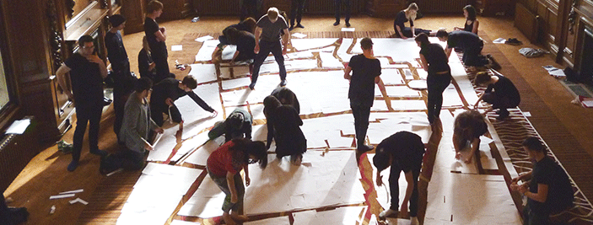

Creative Teaching: supporting risk taking and innovation at UAL

UAL’s annual Learning and Teaching Day 2015

Name of contributor/s
Role, Course, College/ Service
Contact details (all contributors)
Title of Session
Brief description of session and activities and how it fits the theme
Max 300 words
(more info overleaf)
Will students be involved in the session? If so how?
What will participants take away from the session?
Session type ()  A description of all formats overleaf. | Workshop | Paper | Poster Session | Lightning Talk
Technical requirements
Workshop/Papers Duration: 45 minutes
Suggested format for the Workshop:
A short outline (approx. 5 mins) giving the context of the workshop followed by the planned activity. Think about what you want the participants to take away with them, what would be useful for you to gather (feedback, ideas to develop) and how you will keep them engaged in the activity. The workshop is intended to be a fully participatory session where colleagues can reflect on and discuss learning and teaching strategies on the theme. We encourage you to think about creative and visual approaches that particularly suit our university context.
Suggested format for the Paper:
A 15-20 minute oral, visual, film, slide presentation outlining your research, project or curriculum innovation. Allow at least 10 minutes for an activity or discussion to engage participants in the subject and for you to get feedback, generate ideas or actions to develop. It can be useful to prepare 2-3 focussed questions to start the discussion.
Poster Session Duration: 45 minutes
We are encouraging presenters to bring along material that will help to explain in a visual or instructional way, their idea, innovation, project, research etc. This could be through a poster, object/s or artefacts. The Poster Session is also a good format for demonstrating a resource or service you have developed –you can engage colleagues in trying out the material first hand and get instant feedback. If demonstrating, please bring your own equipment.
This session will take place in a large space which you will share with other Poster colleagues. You will have a table, chairs and backboard to display your poster.
Lightning Talks Duration: 5 minutes
Lightning Talks are short think pieces limited to 5 minutes. Each presentation includes a maximum of 20 slides and each slide will advance every 15 seconds. The aim is to keep each talk concise so as to excite and stimulate ideas and discussion as well as enable multiple speakers to contribute to a theme. Lightning Talks are an excellent format for sharing a teaching innovation or an interesting solution to a problem from your experience.
Diary Dates
- We will be holding a short workshop for presenters in early December (date tbc)
- Booking will open in mid November. Please make sure you book a place!
- The L+ T day will take place on Wednesday 14th January at London College of Communication, Elephant & Castle SE1 6SB.

